Django commands-brototype vdeo3

✅ Steps to Write HTML and Display Movie Details in Django
- Create a templates folder in the project root (same level as manage.py)
hello_django/
templates/
- Create hello.html inside the templates folder templates/hello.html

- Add templates directory in settings.py under TEMPLATES → DIRS

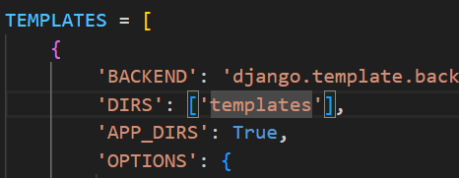
- Write HTML code in templates/hello.html using Django template variables ({{ }})

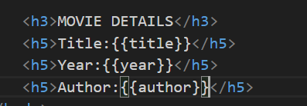
- Import render in hello_app/views.py
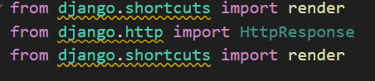
- Create a dictionary with movie details in the view
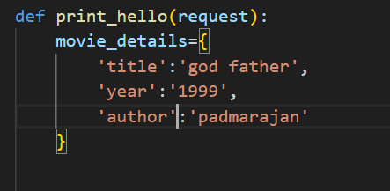
- Return the template using render(request, 'hello.html', context)
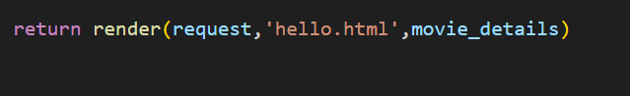

- Import views in hello_django/urls.py
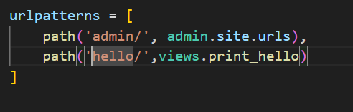

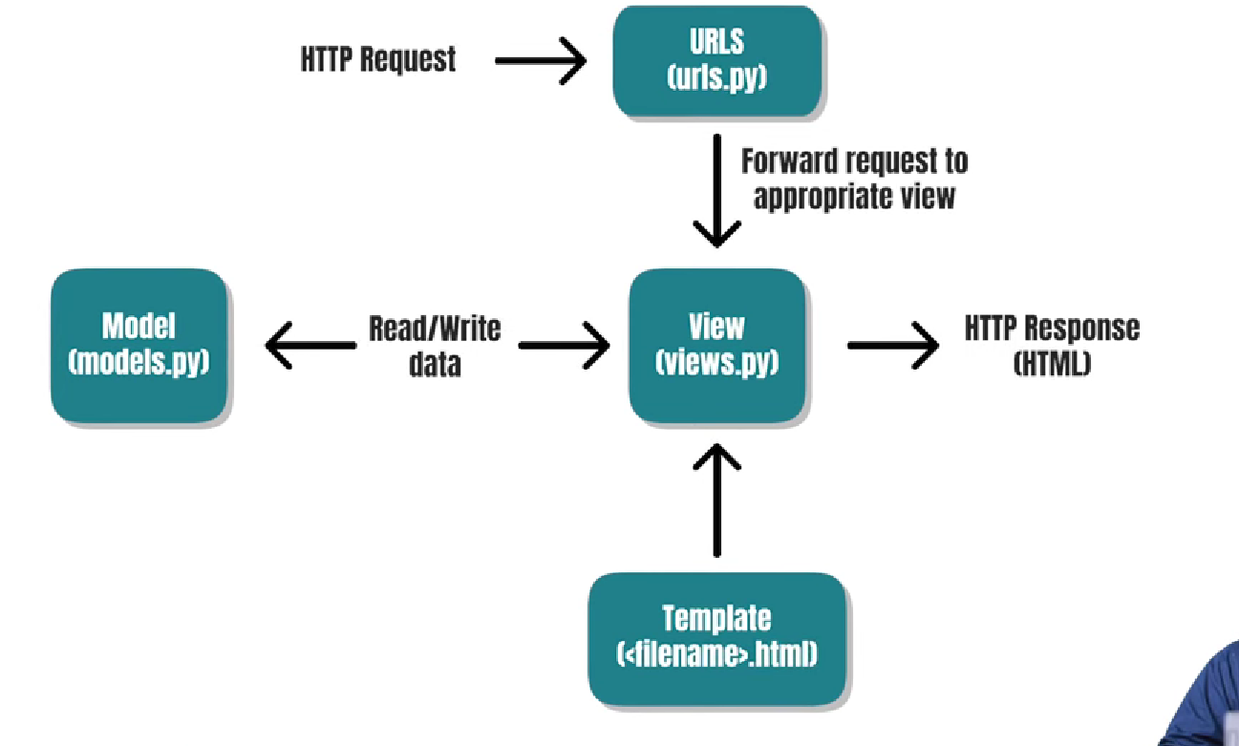

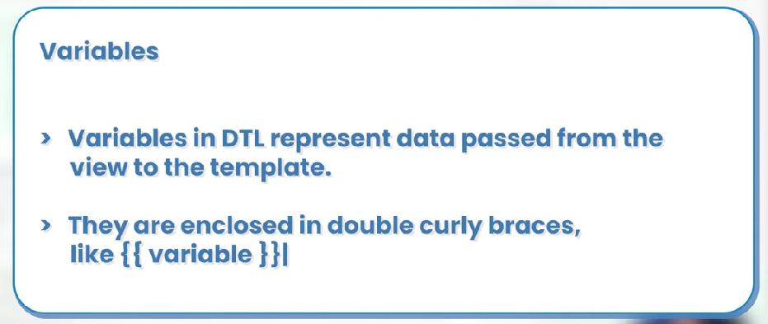
{{ variable }}
{{ variable }}

Variable names consist of any combination of alphanumeric characters and the underscore ("_") but may not start with an underscore, and may not be a number

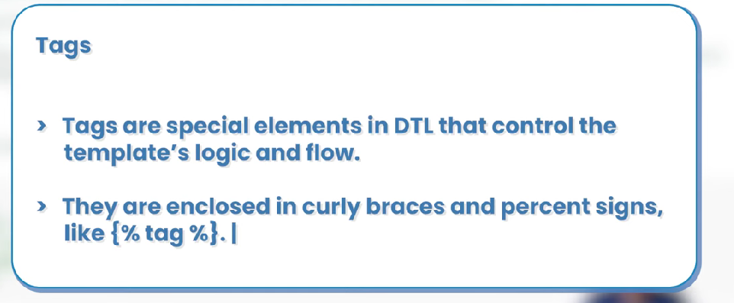
{% tag %}

if, elif, and else
Evaluates a variable, and if that variable is “true” the contents of the block are displayed:
{% if athlete_list %}
Number of athletes: {{ athlete_list|length }}
{% elif athlete_in_locker_room_list %}
Athletes should be out of the locker room soon!
{% else %}
No athletes.
{% endif %}

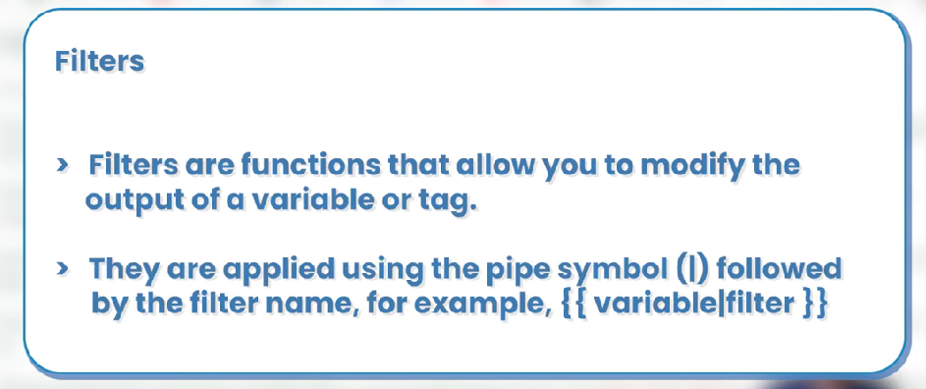

{{ name|lower }}

{{ value|default:"nothing" }}

